SAFE ORDER PICKING

Safe work guidelines
The following information is intended to encourage safe work practices when order picking while on assignment at a customer site. It also supports our safety commitment outlined in our Kelly Health & Safety Policy.

Order picking can result in a variety of muscle and joint injuries and pains from repeatedly or forcefully reaching for and lifting product, using scanners, applying stickers, standing in one position or working overtime. Other injuries and even serious injuries can result from falls and collisions with product, powered equipment or the other workers. In addition, order pickers may be exposed to other hazards such as chemicals.

There is a risk of injury when performing the following tasks:

- Picking product from shelves and bins
- Picking orders using powered order-picking lift trucks
- Lifting heavy or awkward loads
- Congested isles
- Using scanners
- Standing for long periods of time

Risk: Product in Bins and Shelves by Hand
Picking by hand can expose you to stressful postures and forceful actions. These can be harmful if you must reach above your shoulders or far away from your body, bend at the waist or twist to remove product from high and low bins and shelves or lift heavy product. You could also fall when picking product from high locations.

Risks:
- Back Pain
- Muscle strain in your neck, back and shoulders
- Serious injury from falling

Picking high Product:
- Do not climb racks or use the forks of a lift truck to stand on
- Never climb a ladder or any other climbing device unless trained
- Use equipment provided to reach product
- Do not overreach for a product
- Move product slightly to ensure it is not stuck before pulling
- Do not try to save time by picking too many items at once

Picking low Product:
- Make sure heavy product is raised off the floor before lifting
- Use pallets or carts to stack and move product
- Be aware of racks and shelves when reaching to avoid head injury
- Never climb a ladder or any other climbing device unless trained
- Use equipment provided to reach product
- Do not overreach for a product
- Move product slightly to ensure it is not stuck before pulling
- Do not try to save time by picking too many items at once

If lifting is involved, refer to the Kelly ‘Guide to Safe Material handling’ for further guidelines on safe lifting.

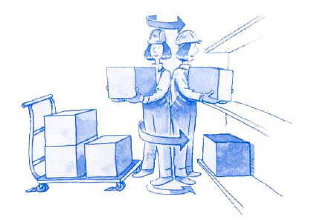

Risk: Picking Product Using Powered Order-Picking Lift Trucks
Improper use of order pickers can result in falls, falling product and collisions with people and racking. Any part of an operator’s body that is outside the platform may be hit by falling objects or shelves.

Risks:
- Collision with other order-pickers, equipment, people or shelves
- Injury from falls or falling product

Before you operate an order-picker:
- Ensure that this is part of your job you were hired to do
- Make sure you have received training and you feel confident in its safe operation
- Use the equipment in the way it is meant to be used
- Do daily checks before using
- Report any issues with the equipment to your supervisor

While operating an order-picker:
- Make sure the area you are working in is clear and level
- Look for obstructions such as pipes, shelves, people and other equipment
- Obey traffic rules and only use order-picker in designated areas
- Watch for co-workers and other order-pickers
- Ensure product is secure before moving
- Do not overload your order-picker or have product hanging over the sides

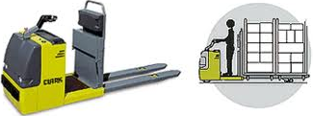

Risk: Lifting Heavy Loads by Hand
Picking orders may involve lifting heavy or bulky loads that can put stress on your back, shoulders and hands. Loads may also fall on your feet or pinch you fingers when they are being put down.

Risks:
- Muscle strain in your back and shoulders
- Injury to your hands
- Injury from falls or falling product

Before you lift:
- Warm up by stretching muscles
- Wear recommended safety shoes and gloves
- Size up your load with a quick glance to determine size and shape
- Place a hand on the item and tilt or slide the object to roughly determine the weight
- Observe the area to ensure adequate room to avoid twisting and manoeuvring
- If the load is heavy, ask for help

While you are lifting:
- Ensure a firm grip
- Face the direction you are moving to avoid twisting or turning while carrying product
- Do not Twist your body while lifting
- Lift with your legs, not your back
- Wear recommend safety shoes and gloves

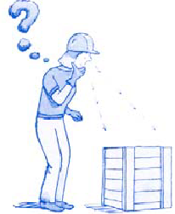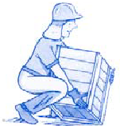

Risk: Congested Isles
Congestion is created when product is left in aisles or when there are several pickers working in the same aisle. The congestion can lead to collisions, slips, trips and falls.

Risks:
- Injury to your hands and feet
- Injury from falls or falling product

Safe Guidelines:
- Store item in appropriate areas
- Report congestion to your supervisor
- Let others know you are in the area by telling them or using horns
- Follow traffic rules
- Never assume other people see you

Risk: Using Scanners
Repeated use of scanners puts stress on your wrists, hands and elbows.

Risks:
- Wrist, hand and elbow injury

Safe Guidelines:
- Make sure you are trained in proper scanning techniques
- Follow any scanning procedures established by the customer
- If issues arise with the use of the scanner, report to your supervisor immediately

Risk: Standing for Long Periods of Time
When you stand for long periods of time, your leg muscles continually support your body which can cause tiredness.

Risks:
- Tendon and muscle strain
- Low back pain
- Sore feet

Safe Guidelines:
- Make sure you are wearing the right footwear for the job
- Wear padded shoe inserts that support your feet
- Take mini breaks sitting down to relieve stress on your leg muscles

References:
- KellyWeb Canada > Health & Safety > Branch Safety Requirements & Inspections
- Occupational Health & Safety Legislation. Industrial Establishment Regulations (O. Reg. 851/90)
Section 45:
“Materials, articles or things,
- required to be lifted, carried or moved, shall be lifted, carried or moved in such a way and with such precautions and safeguards, including protective clothing, guards or other precautions as will ensure that the lifting, carrying or moving of the material, articles or things does not endanger the safety of any worker;
- shall be transported, placed or stored so that the material, articles or things,
- will not tip, collapse or fall, and
- can be removed or withdrawn without endangering the safety of any worker; and
c) to be removed from a storage area, pile or rack, shall be removed in a manner that will not endanger the safety of any worker.”

Contacts
- Holly Hardison, Safety, Health & Environmental Manager, +1 226 759 5839
- Cheri Duggan, Global Senior Safety, Health & Environmental Manager, +1 661 204 2959

